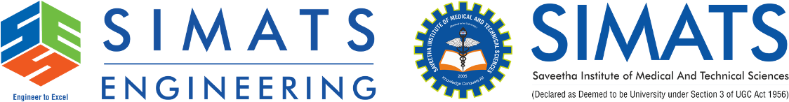
ECA1001

MICROPROCESSORS AND MICROCONTROLLERS

MASTER RECORD WITH TEST CASES

NAME | ROHAN P T
REGISTER NUMBER | 192424112
COURSE CODE | ECA1001
COURSE | MICROPROCESSORS AND MICROCONTROLLERS
MASTER RECORD WITH TEST CASES

1. Arithmetic Operations in 8085 Microprocessors
a. 8-BIT ADDITION WITH CARRY USING DIRECT ADDRESSING
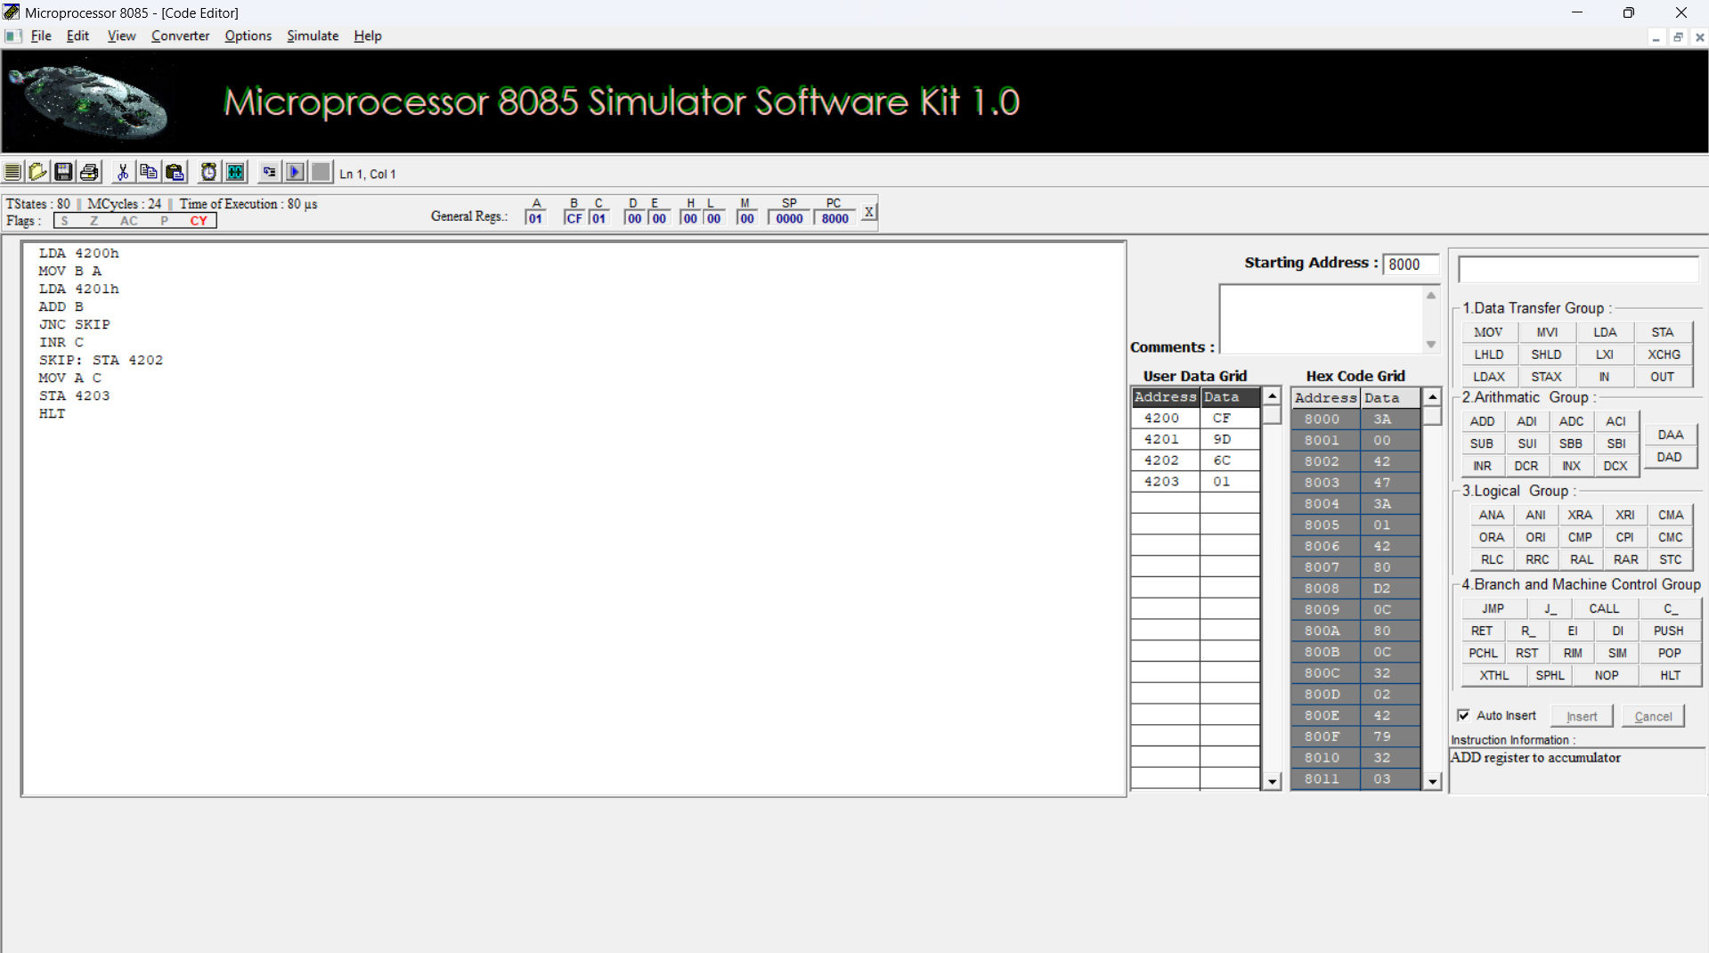

b. 8-BIT ADDITION USING INDIRECT ADDRESSING
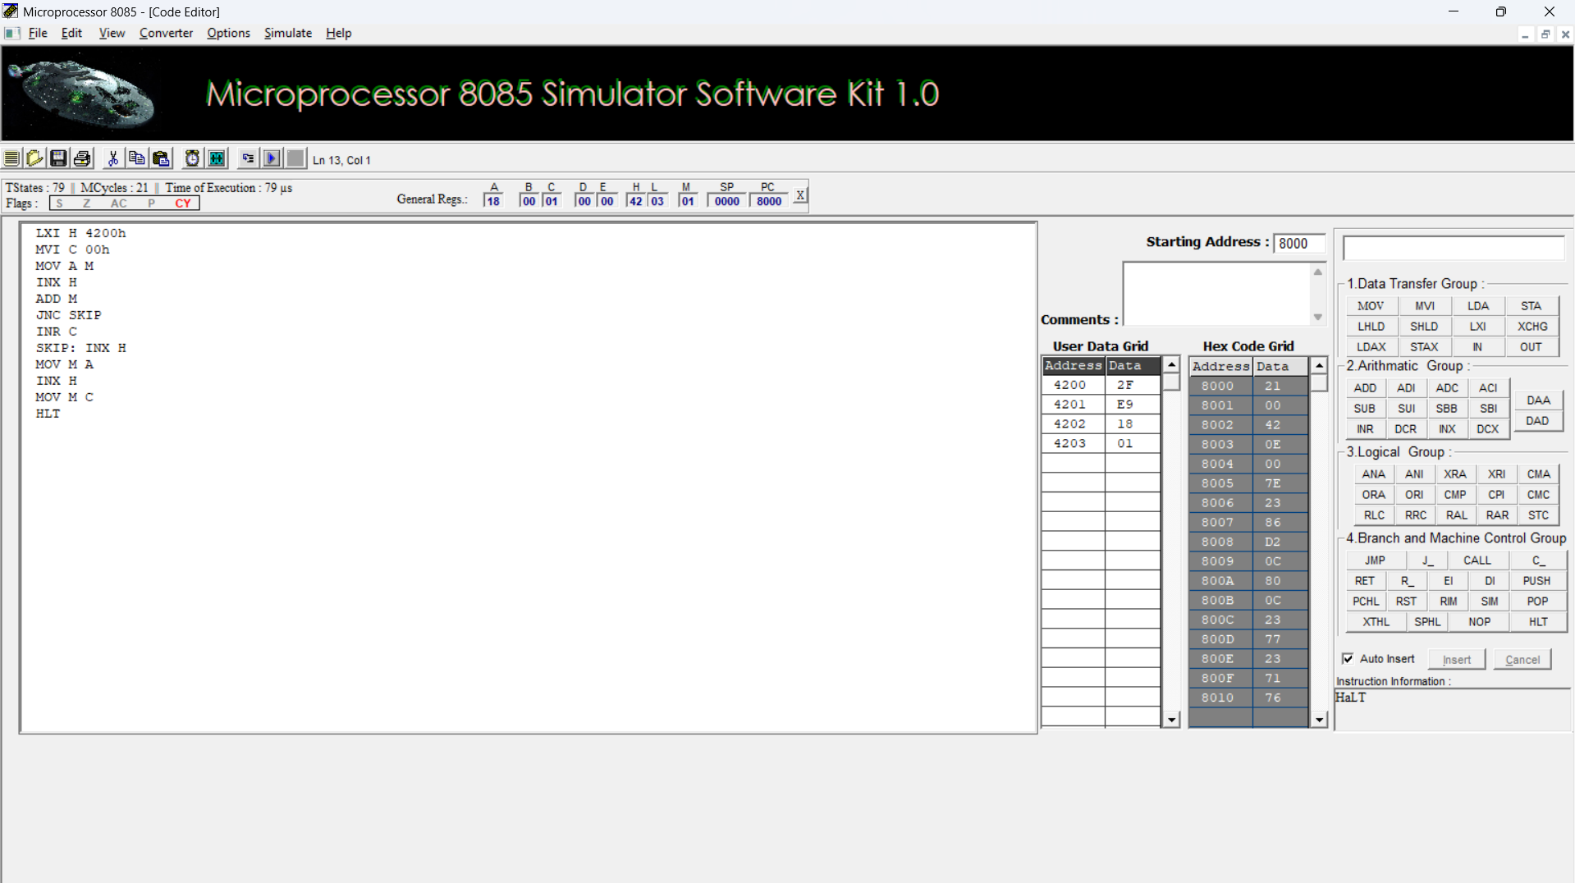

c. 8-BIT SUBTRACTION WITHOUT BORROW
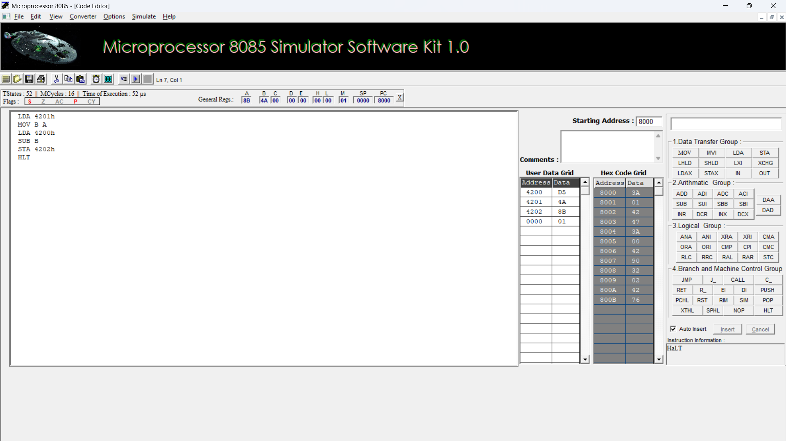

d. 8-BIT SUBTRACTION WITH BORROW USING DIRECT ADDRESSING
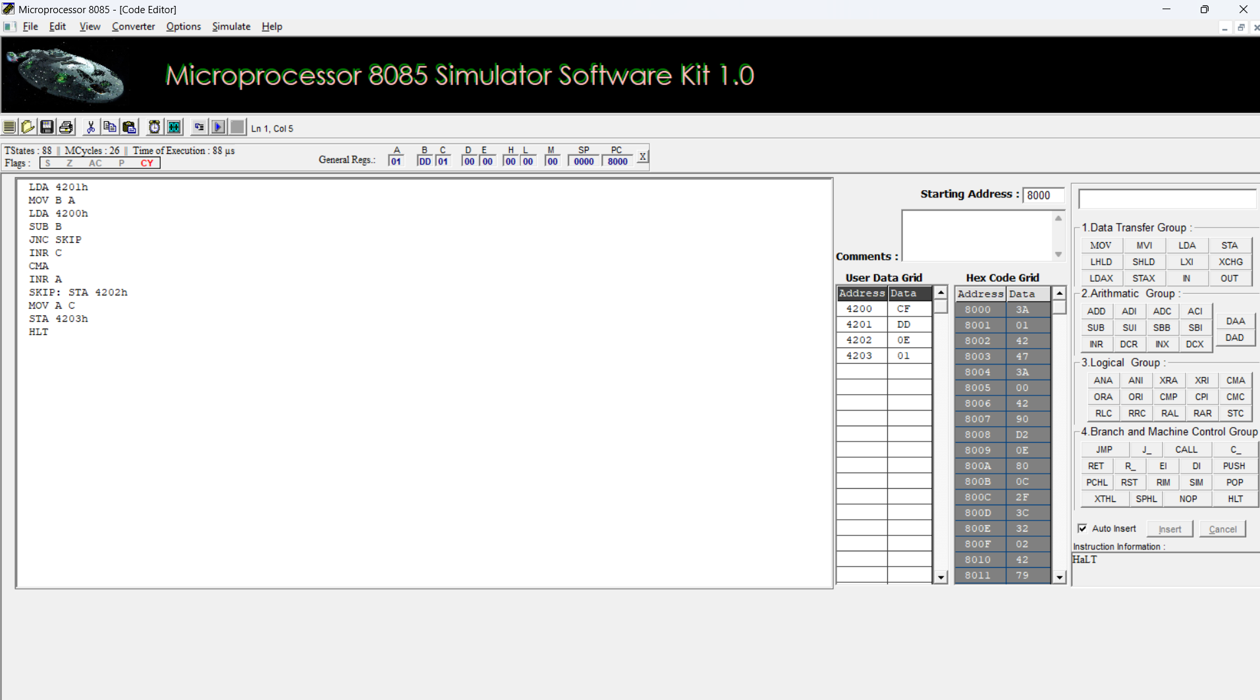

e. 8-BIT MULTIPLICATION OPERATIONS USING 8085 MICROPROCESSOR
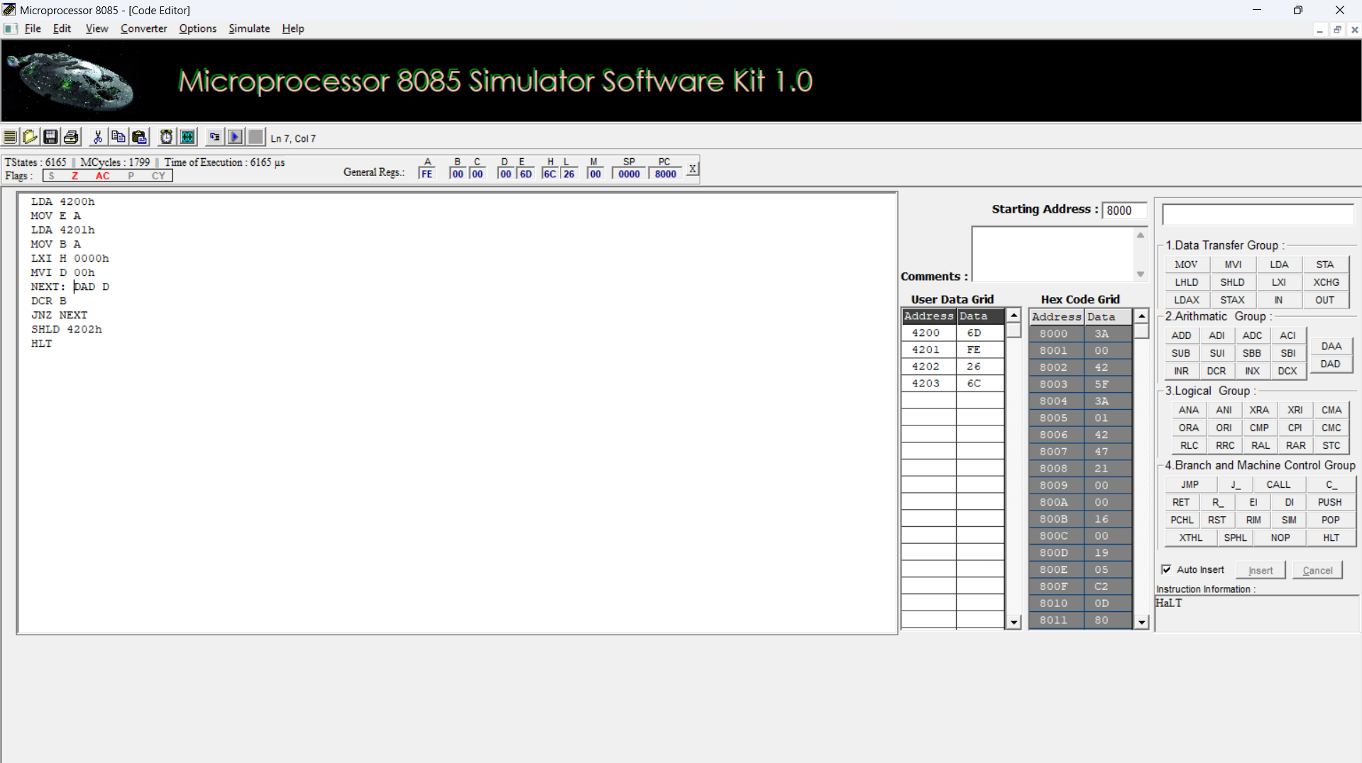

f. 8-BIT DIVISION OPERATIONS USING 8085 MICROPROCESSOR
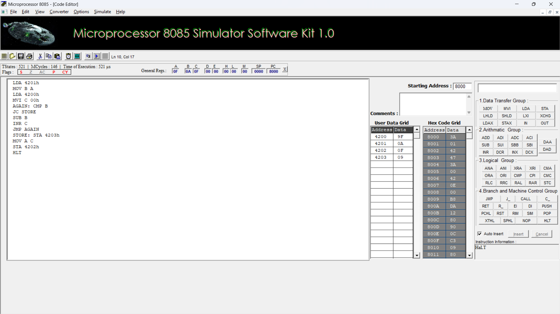

2a.SORT AN ARRAY OF DATA IN ASCENDING ORDER
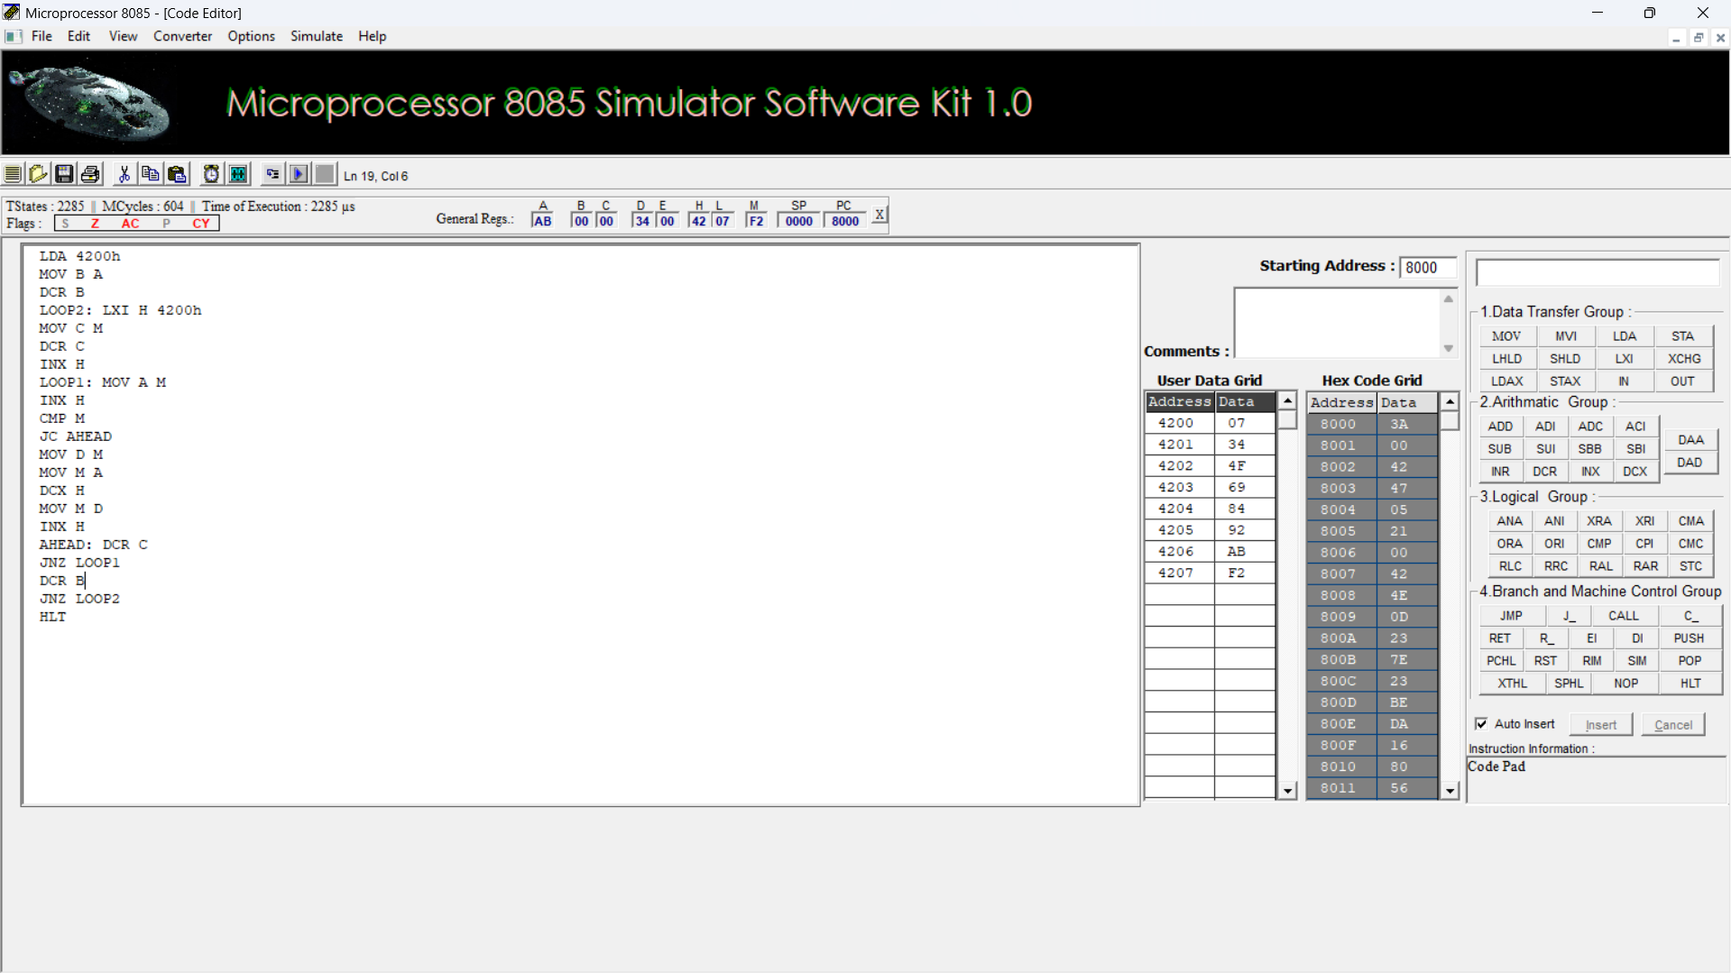

2b. SORT AN ARRAY OF DATA IN DESCENDING ORDER
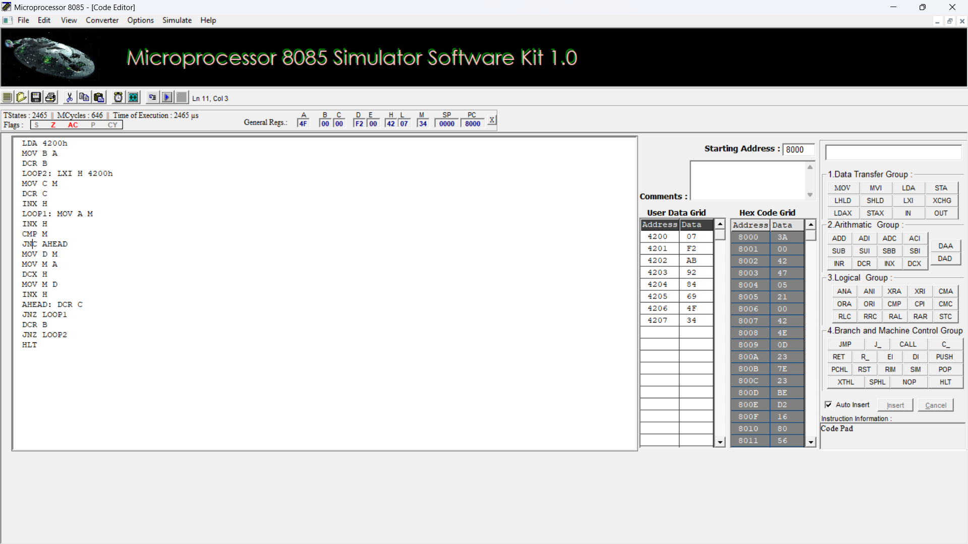

- ASCII CODE TO HEX CODE CONVERSION
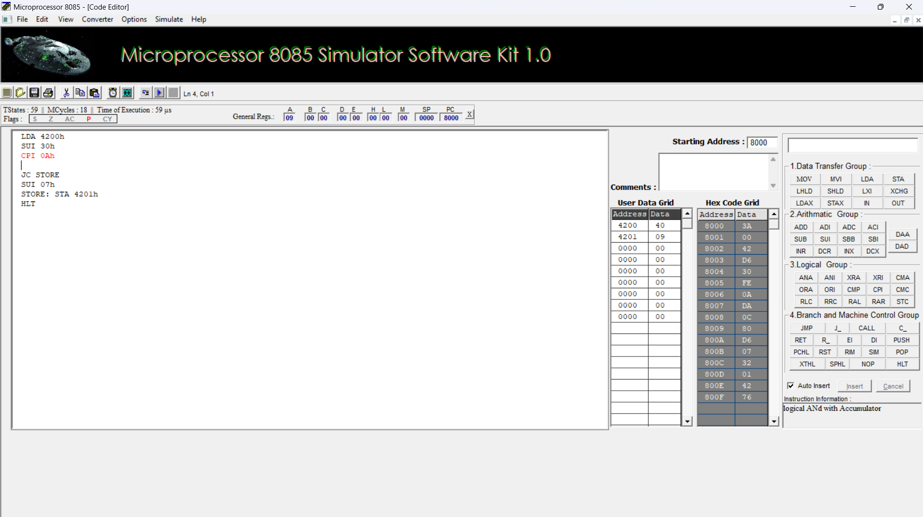
- TRANSFERRING A BLOCK OF DATA BETWEEN MEMORY LOCATIONS
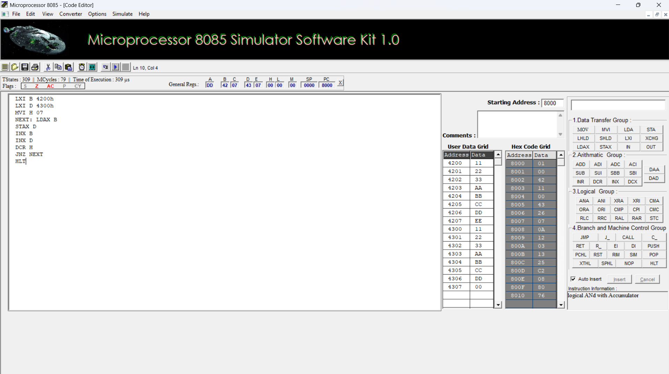

5.Perform Masking (AND), Setting (OR) of lower nibbles and One’s and Two’s complement on given data using 8085 Microprocessor

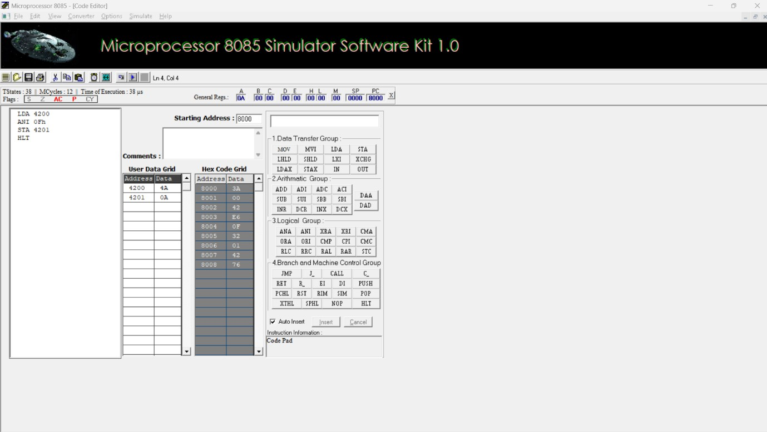
MASKING AND SETTING OF LOWER NIBBLES ON GIVEN DATA

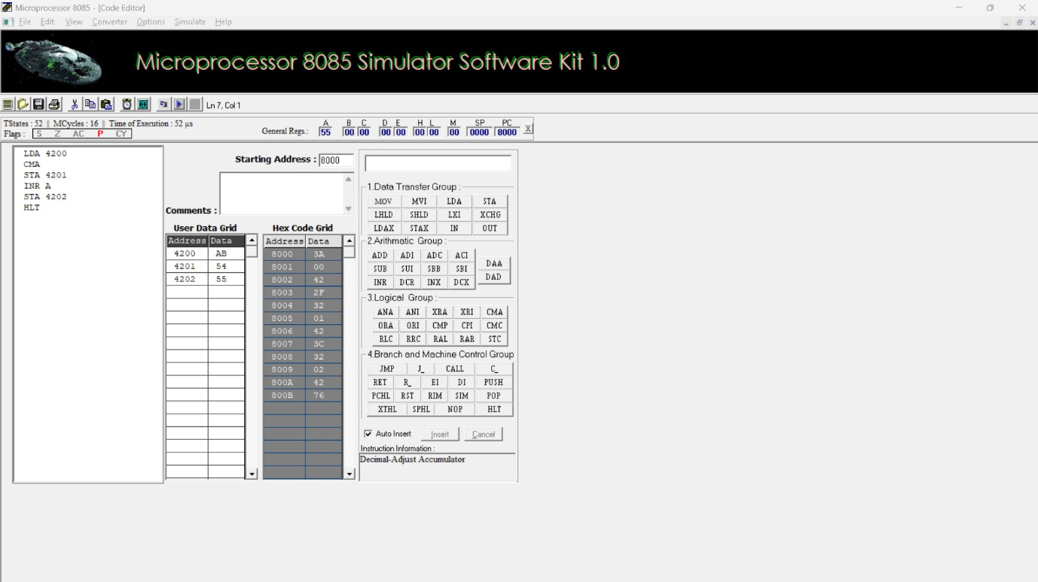
ONE’S AND TWO’S COMPLEMENT

